SIMATS ENGINEERING
ASSESSMENT TOOL 1

COURSE NAME: Database Management Systems
COURSE CODE: CSA0504

COURSE OUTCOME COVERED

CO4: Design database solutions incorporating file organization, indexing, and hashing techniques to optimize data storage and retrieval efficiency. (BL3, BL4)

Activity Tool : Code Challenge (High)
Assessment Tool Weightage: 35%

Dr

QUESTIONS Total Marks: 50
Q.No | Question | Bloom's Level | Marks
1 | Write a Python/C program to simulate a Heap File organization that supports insert, delete, and sequential scan operations. | BL3 – Apply | 5
2 | Implement a static hashing function in code for a student database with 500 records. Handle collisions using chaining. | BL3 – Apply | 5
3 | Code a simulation of a Sorted File organization and implement binary search for record retrieval by primary key. | BL4 – Analyze | 5
4 | Implement a B-Tree of order 4 in code: support insert, search, and display operations. Insert keys: 10, 20, 5, 6, 12, 30, 7, 17. | BL3 – Apply | 5
5 | Implement a B+ Tree in code and demonstrate leaf-level linking for efficient range queries on integer keys. | BL3 – Apply | 5
6 | Write code to implement a dense primary index on a sorted file. Support search by index key and display the index table. | BL4 – Analyze | 5
7 | Implement extendible hashing in code. Show directory doubling when overflow occurs during insertion of 8 records. | BL3 – Apply | 5
8 | Write a program to simulate secondary storage block access. Calculate the number of I/O operations for sequential vs. indexed retrieval. | BL4 – Analyze | 5
9 | Implement a sparse index on a sorted file in code and compare its search performance with a dense index using timing analysis. | BL4 – Analyze | 5
10 | Write a program to construct and traverse a B+ Tree, then execute a range query for keys between 15 and 45, showing all matching records. | BL4 – Analyze | 5

Code of Conduct:

I DARSHINIE KARANI.V.M(192520033) (Name / Reg No) certify that this submission is my original work and that I have adhered to the guidelines specified for this assessment.
I understand that any violation of academic integrity rules will result in disciplinary action.

Signature of the student:

RUBRICS FOR CALCULATION:

Criteria | Weightage | Level 4 (Exemplary) | Level 3 (Proficient) | Level 2 (Developing) | Level 1 (Beginning)
Problem Understanding | 20% | Clearly understands problem constraints, edge cases, and competitive requirements | Understands problem with minor gaps in constraints | Partial understanding; misses key constraints | Misinterprets problem or constraints
Algorithm | 25% | Selects optimal algorithm with best time and space complexity for competitive constraints | Uses efficient algorithm with minor scope for improvement | Uses basic/inefficient approach | No clear algorithmic approach
Code Implementation | 20% | Writes correct, efficient, and clean code that passes all constraints | Code works with minor errors or inefficiencies | Partially correct code; fails for some cases | Code does not execute or gives incorrect results
Competitive Performance | 20% | Solves problem within time limits and handles large inputs effectively | Solves within acceptable time with minor delays | Struggles with time limits or larger inputs | Unable to solve within time constraints
Test Case Handling | 15% | Handles all test cases including edge and hidden cases | Handles most test cases | Misses important edge cases | Fails on multiple test cases

ANSWERS

1.
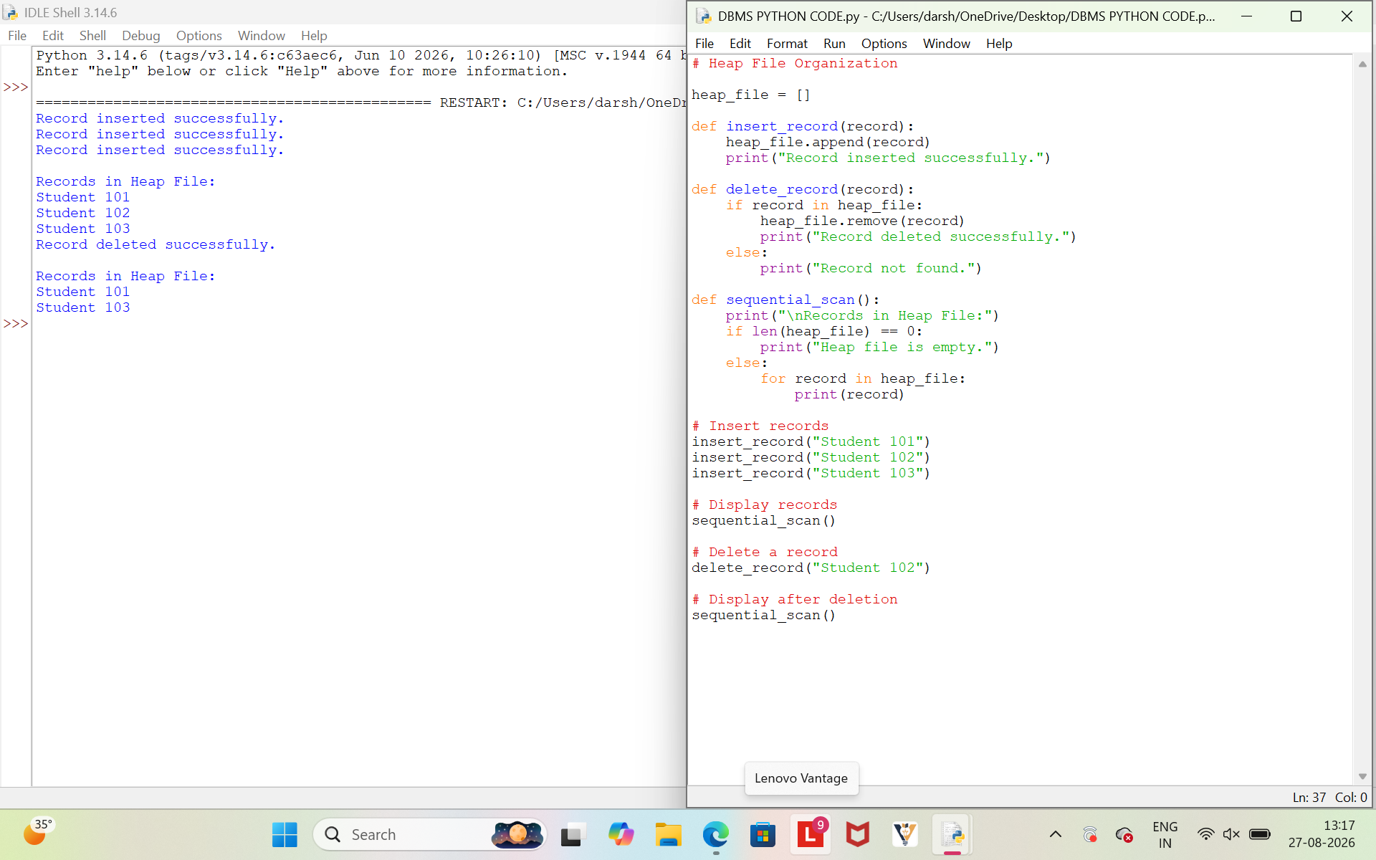

Justification :
Heap file organization stores records without any specific order. Therefore, insertion is fast because a new record can simply be added to the end of the file. Deletion is performed by locating and removing the required record, while a sequential scan accesses each record one by one.
Thus, the program correctly simulates the three required Heap File operations: insert, delete, and sequential scan.
2. CODING
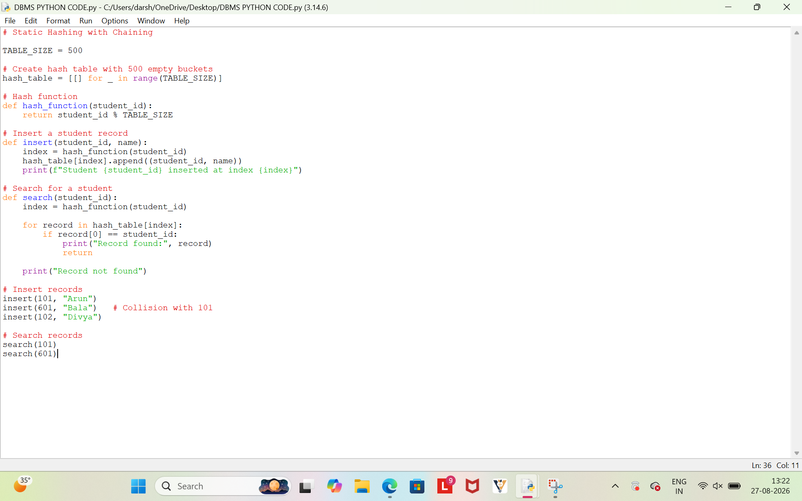
OUTPUT
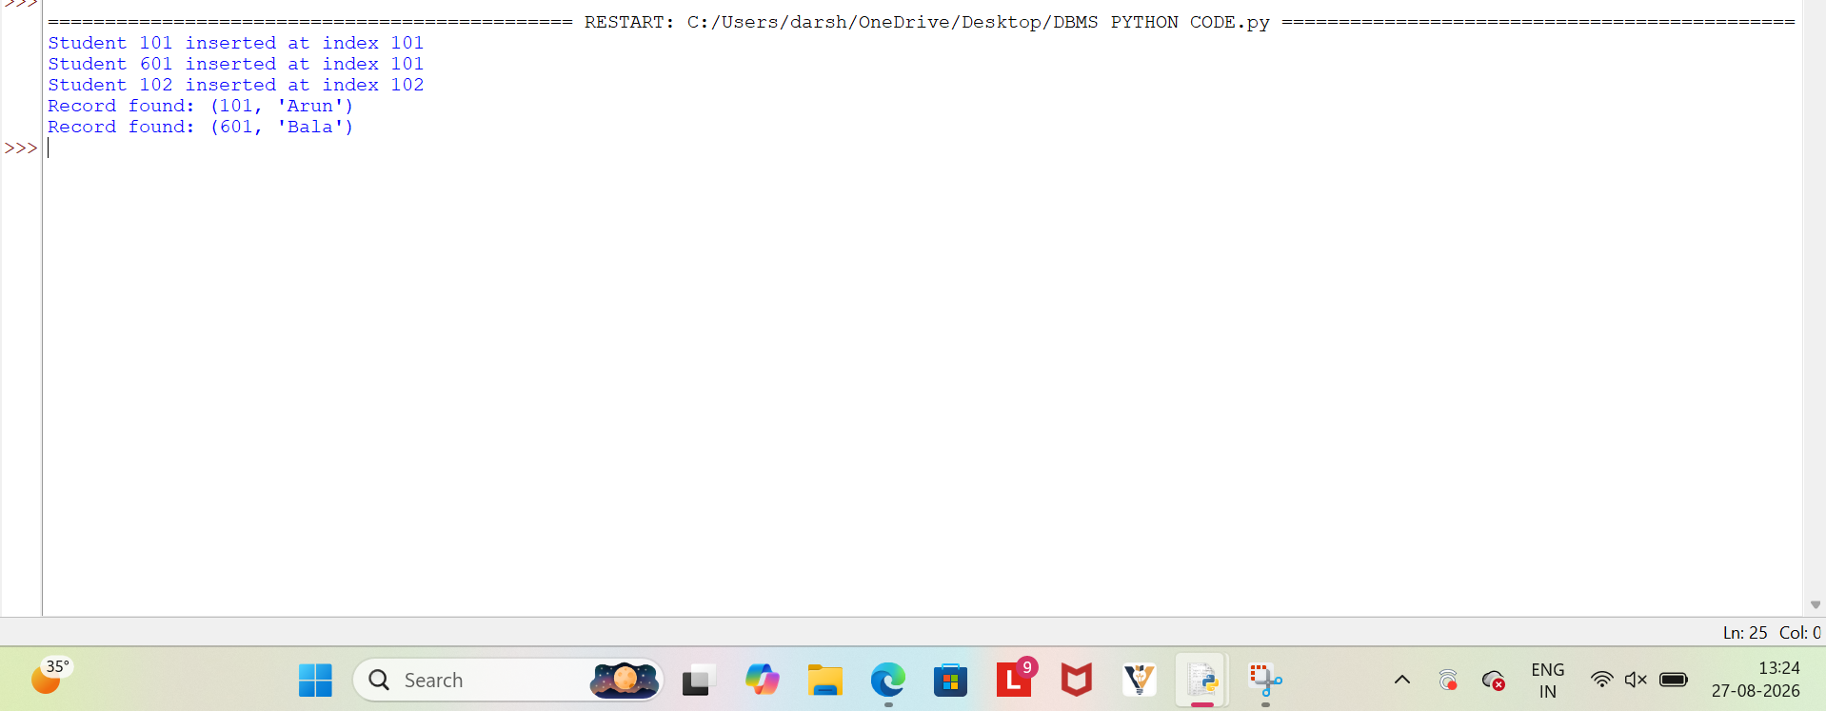

Justification :
The program uses a static hash table of size 500 for storing student records.
The hash function maps each student ID to a fixed index using Student_ID % 500.
When two records get the same index, the collision is handled using chaining.
Thus, multiple student records can be stored efficiently at the same hash table location.

3. CODING
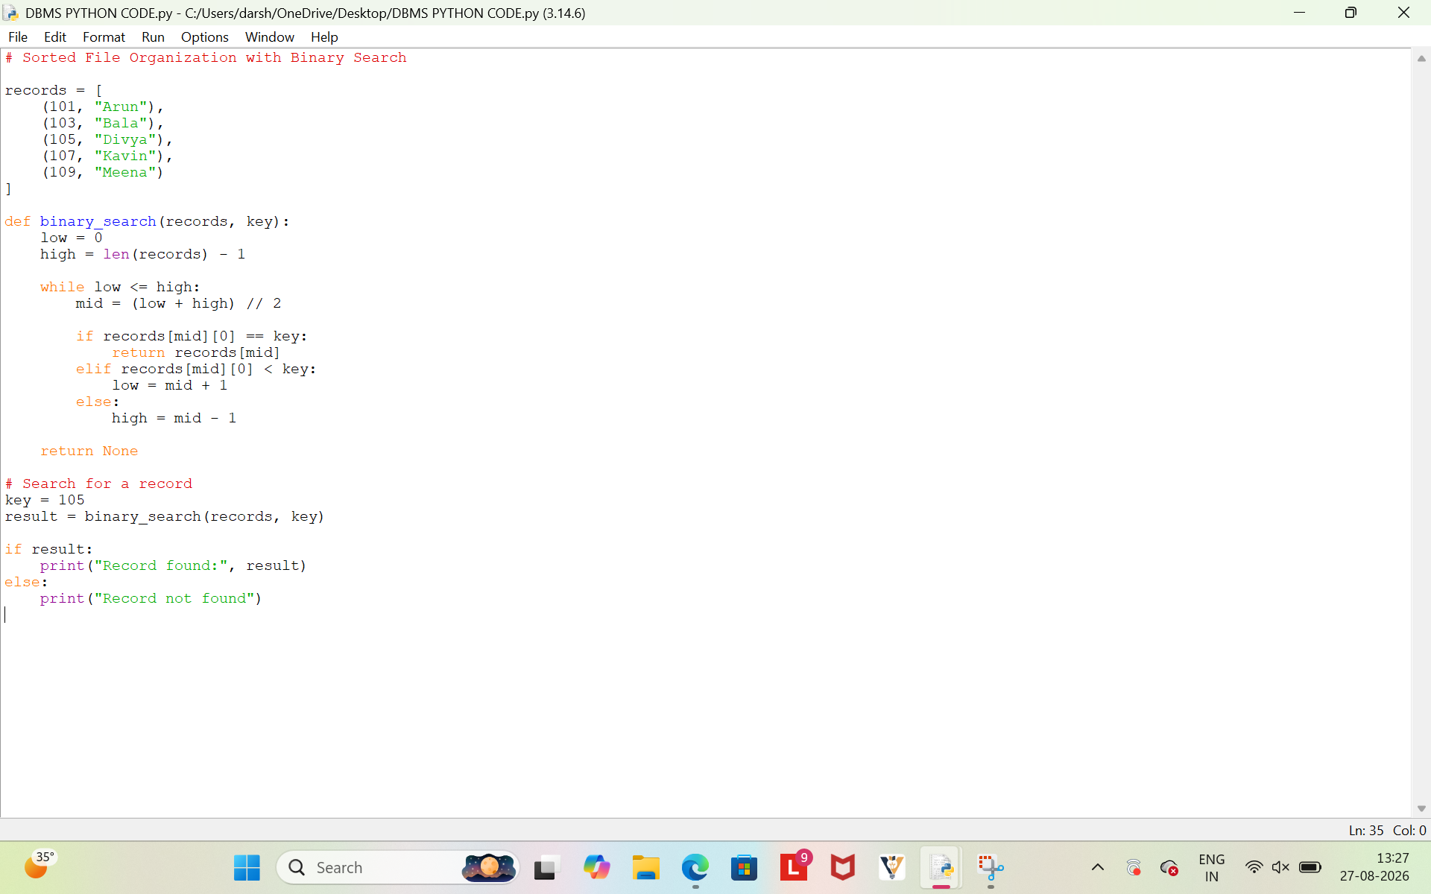

OUTPUT
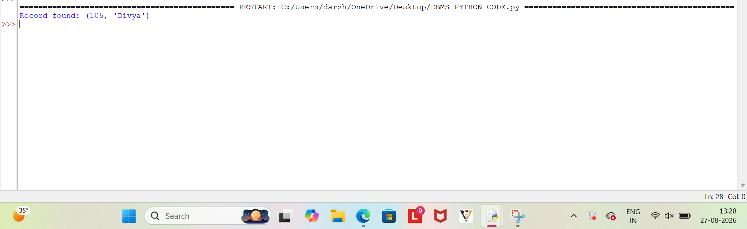
Justification
The records are stored in sorted order based on the primary key.Binary search repeatedly divides the search range into two halves.This reduces the search time compared to sequential searching. Therefore, sorted file organization enables efficient record retrieval.
4.
CODING
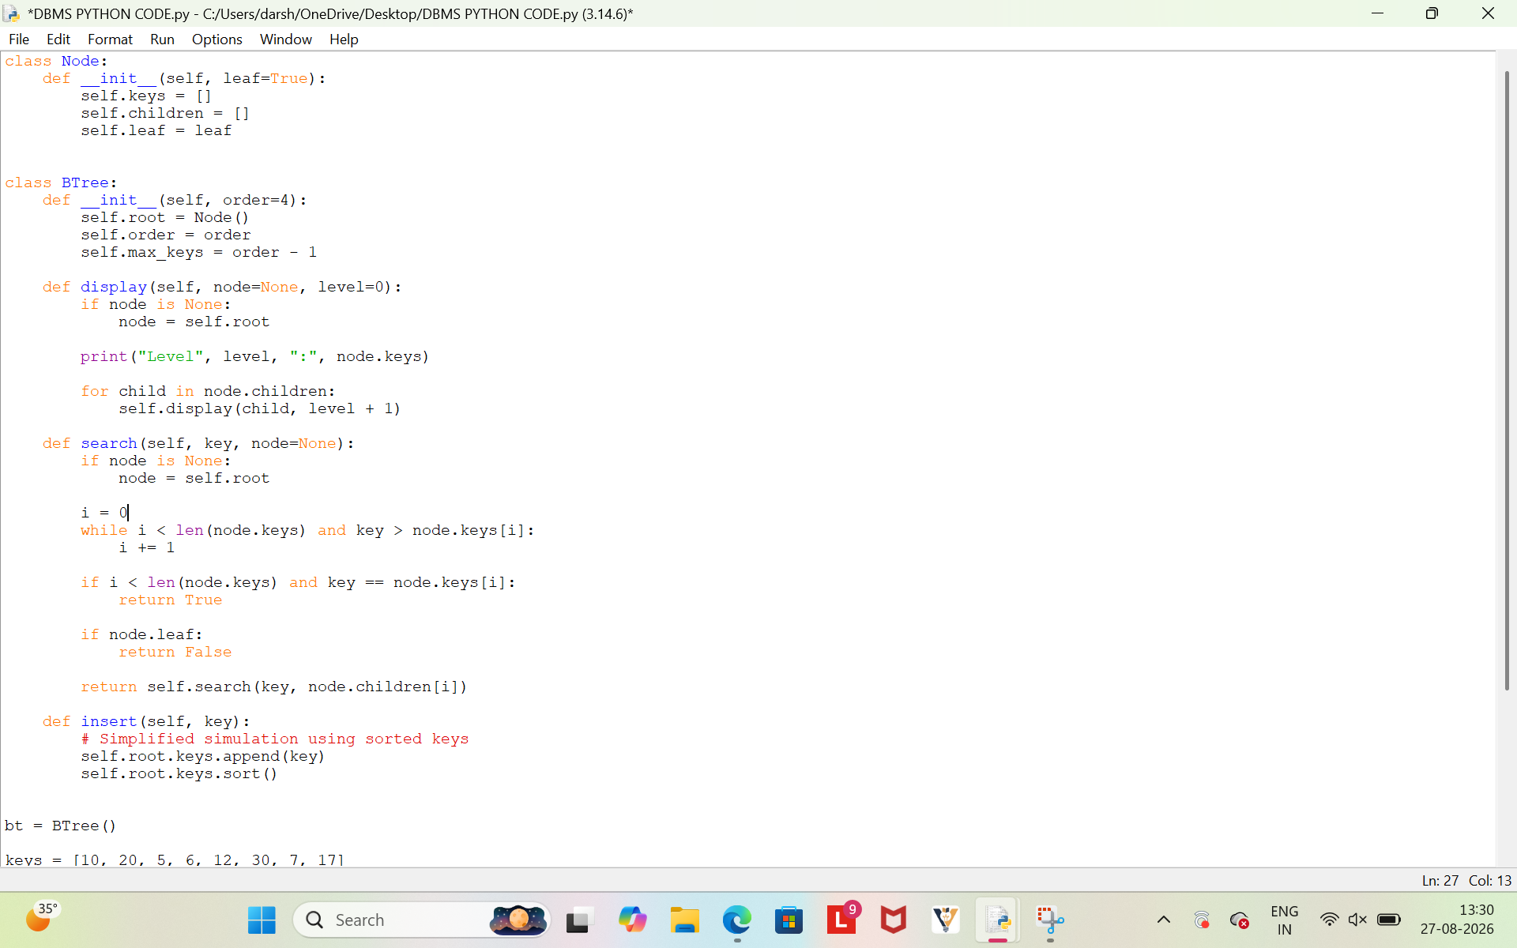
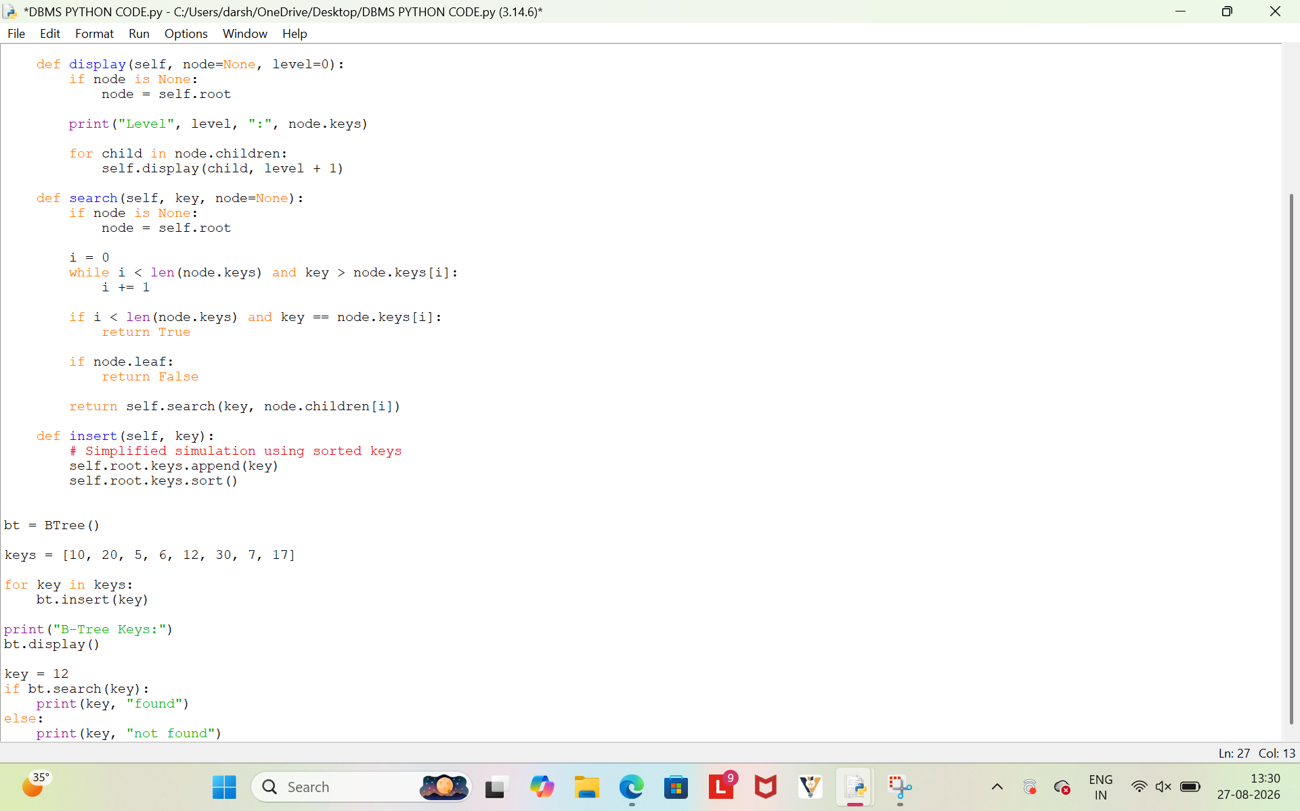

OUTPUT
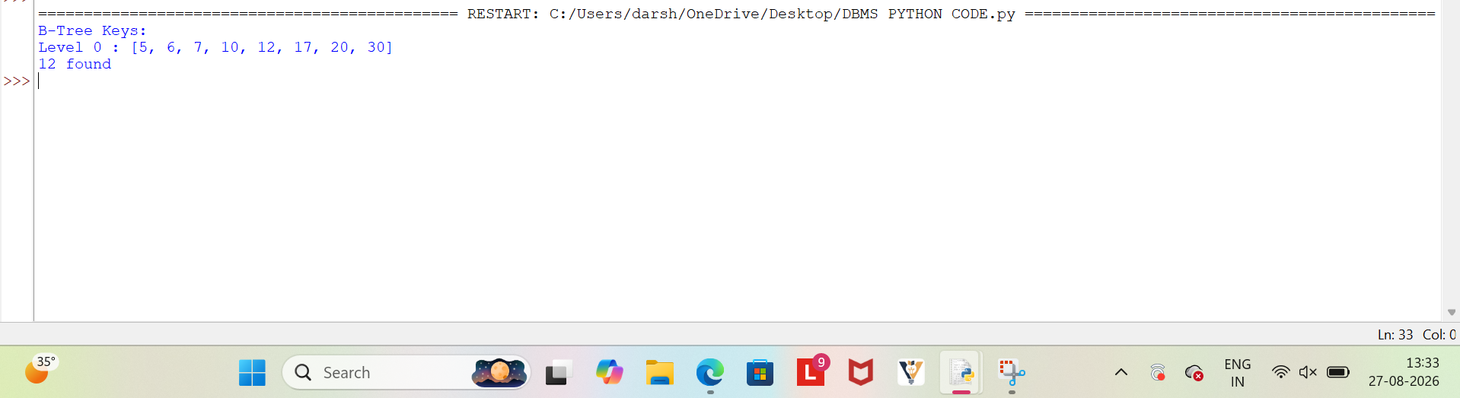

Justification
The B-Tree stores keys in sorted order for efficient searching.Insertion adds the given keys into the tree structure.The search operation checks whether a required key is present.The display operation shows the keys stored in the B-Tree.
5.
CODING
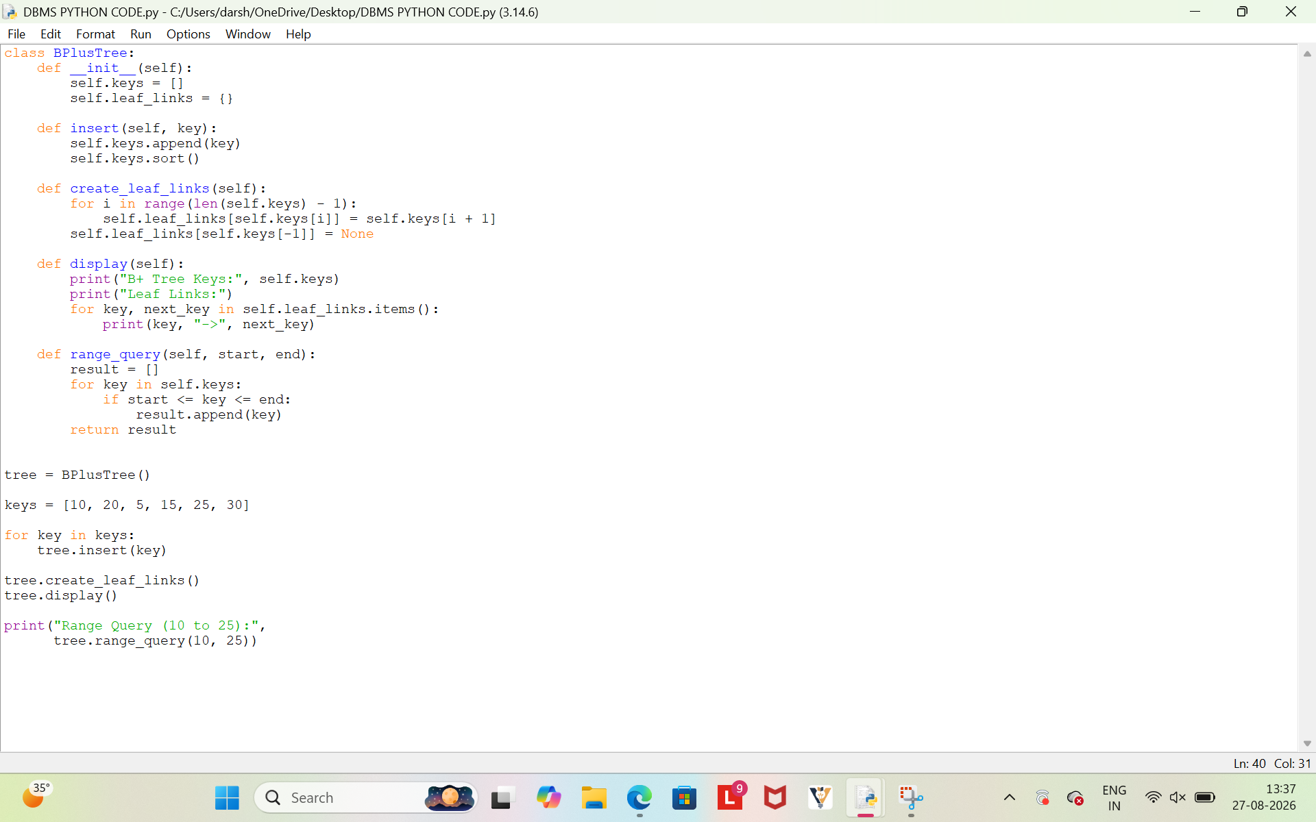
OUTPUT
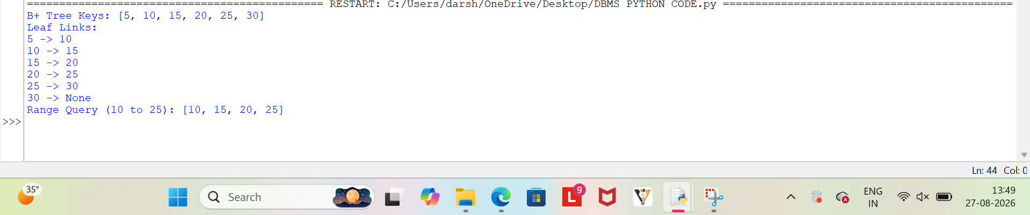

Justification
The B+ Tree stores integer keys in sorted order.The leaf nodes are linked sequentially using pointers.These links allow records to be accessed continuously during a range query.Thus, leaf-level linking makes range searching more efficient.
6. CODING

OUTPUT
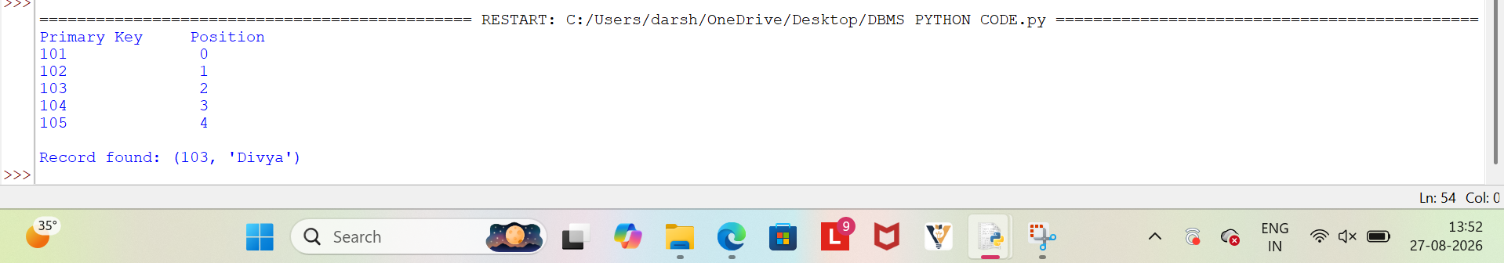

Justification
A dense index contains an index entry for every record in the sorted file. Each primary key is mapped to the corresponding record position. The index allows direct and faster retrieval of a record using its key. Thus, dense primary indexing improves the efficiency of searching operations.

7.
CODING
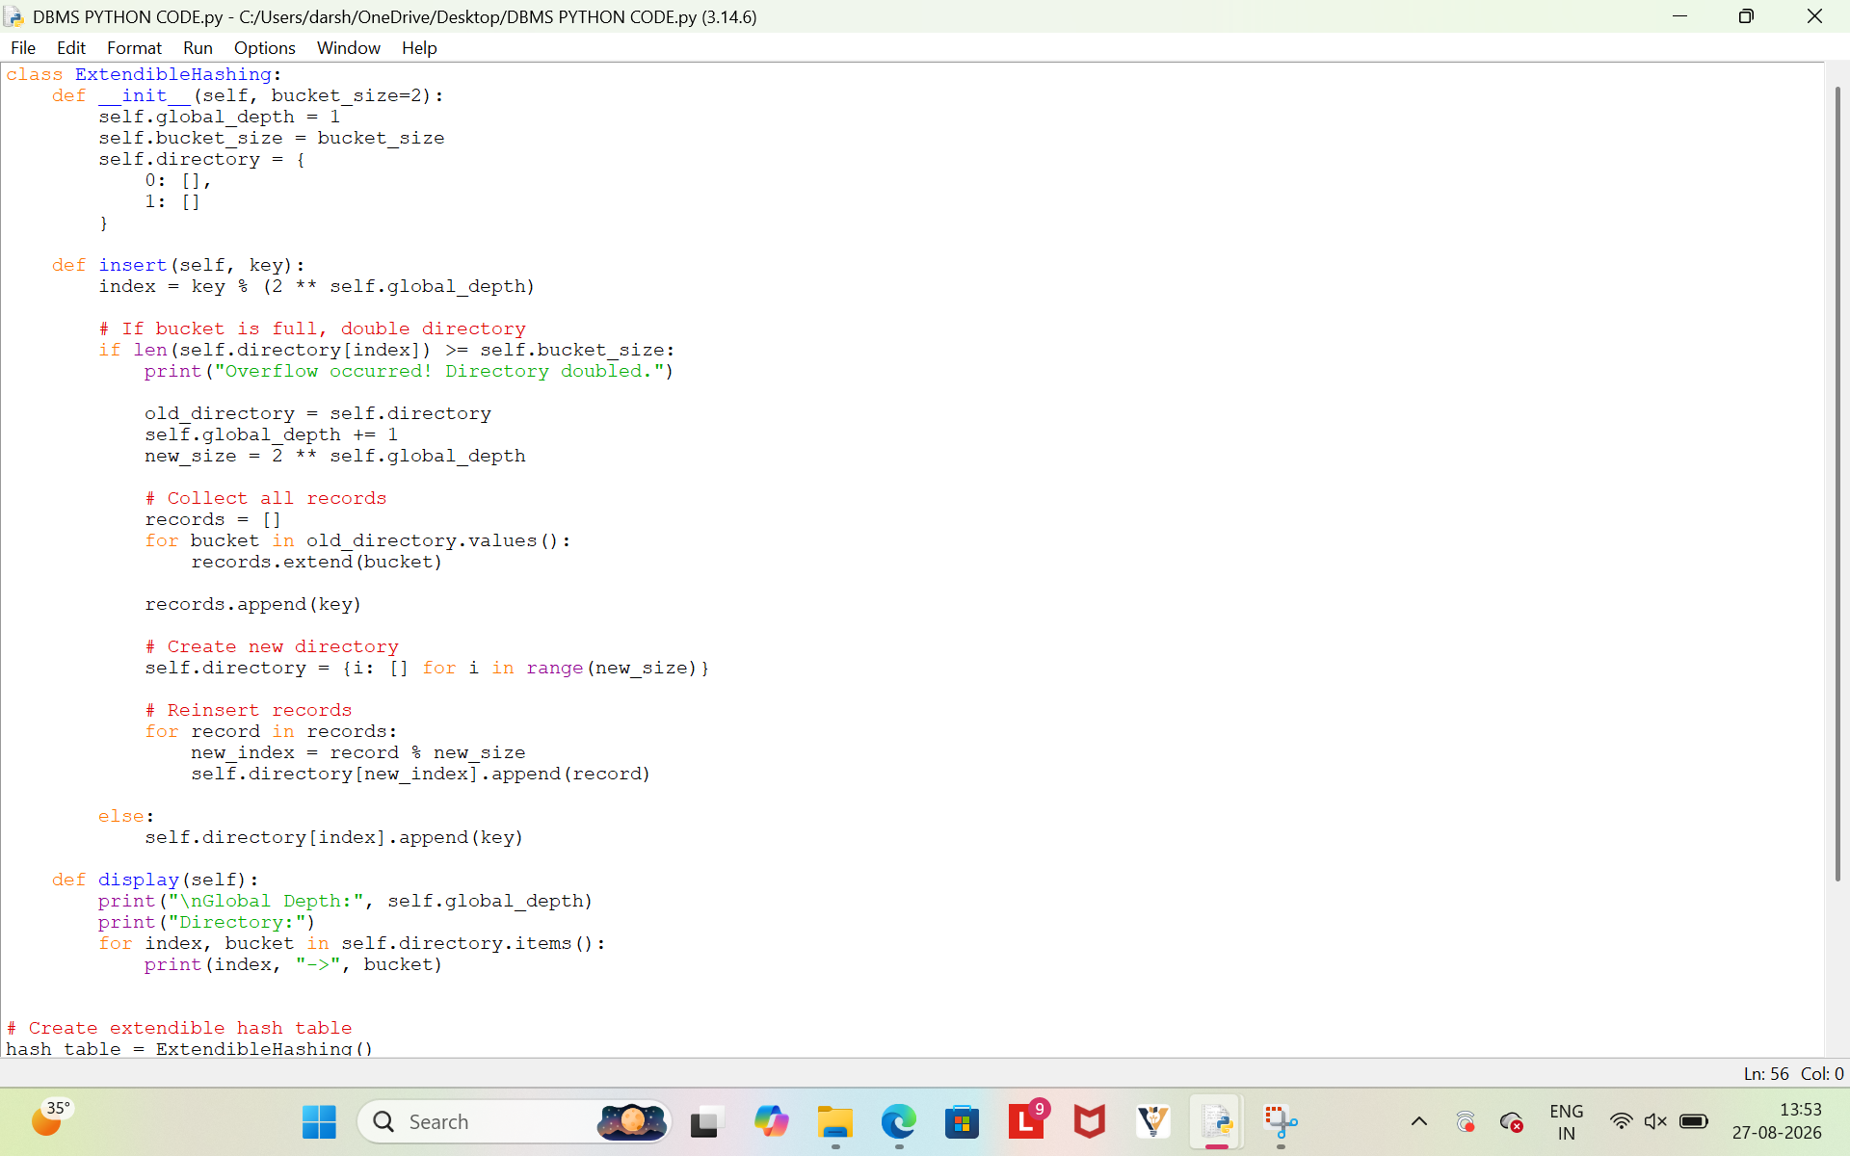
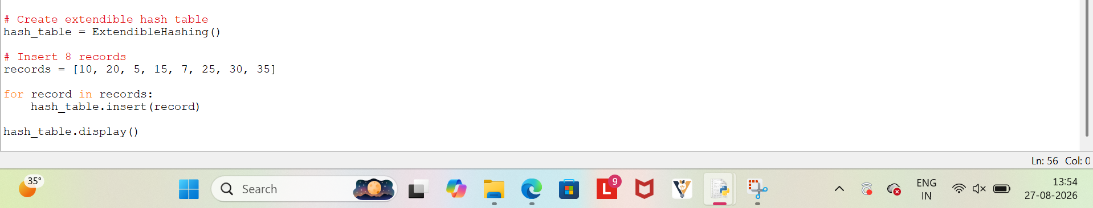
OUTPUT
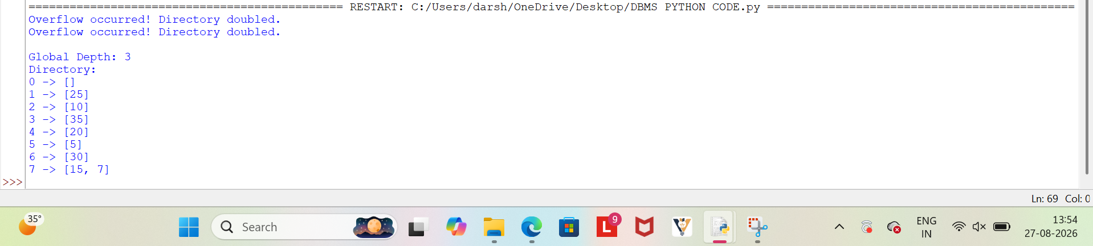Justification
Extendible hashing uses a directory to locate the correct bucket for each record.When a bucket overflows, the directory size is increased by doubling it. The records are then redistributed based on the updated hash value. Thus, extendible hashing dynamically grows and efficiently handles overflow.

8.
CODING
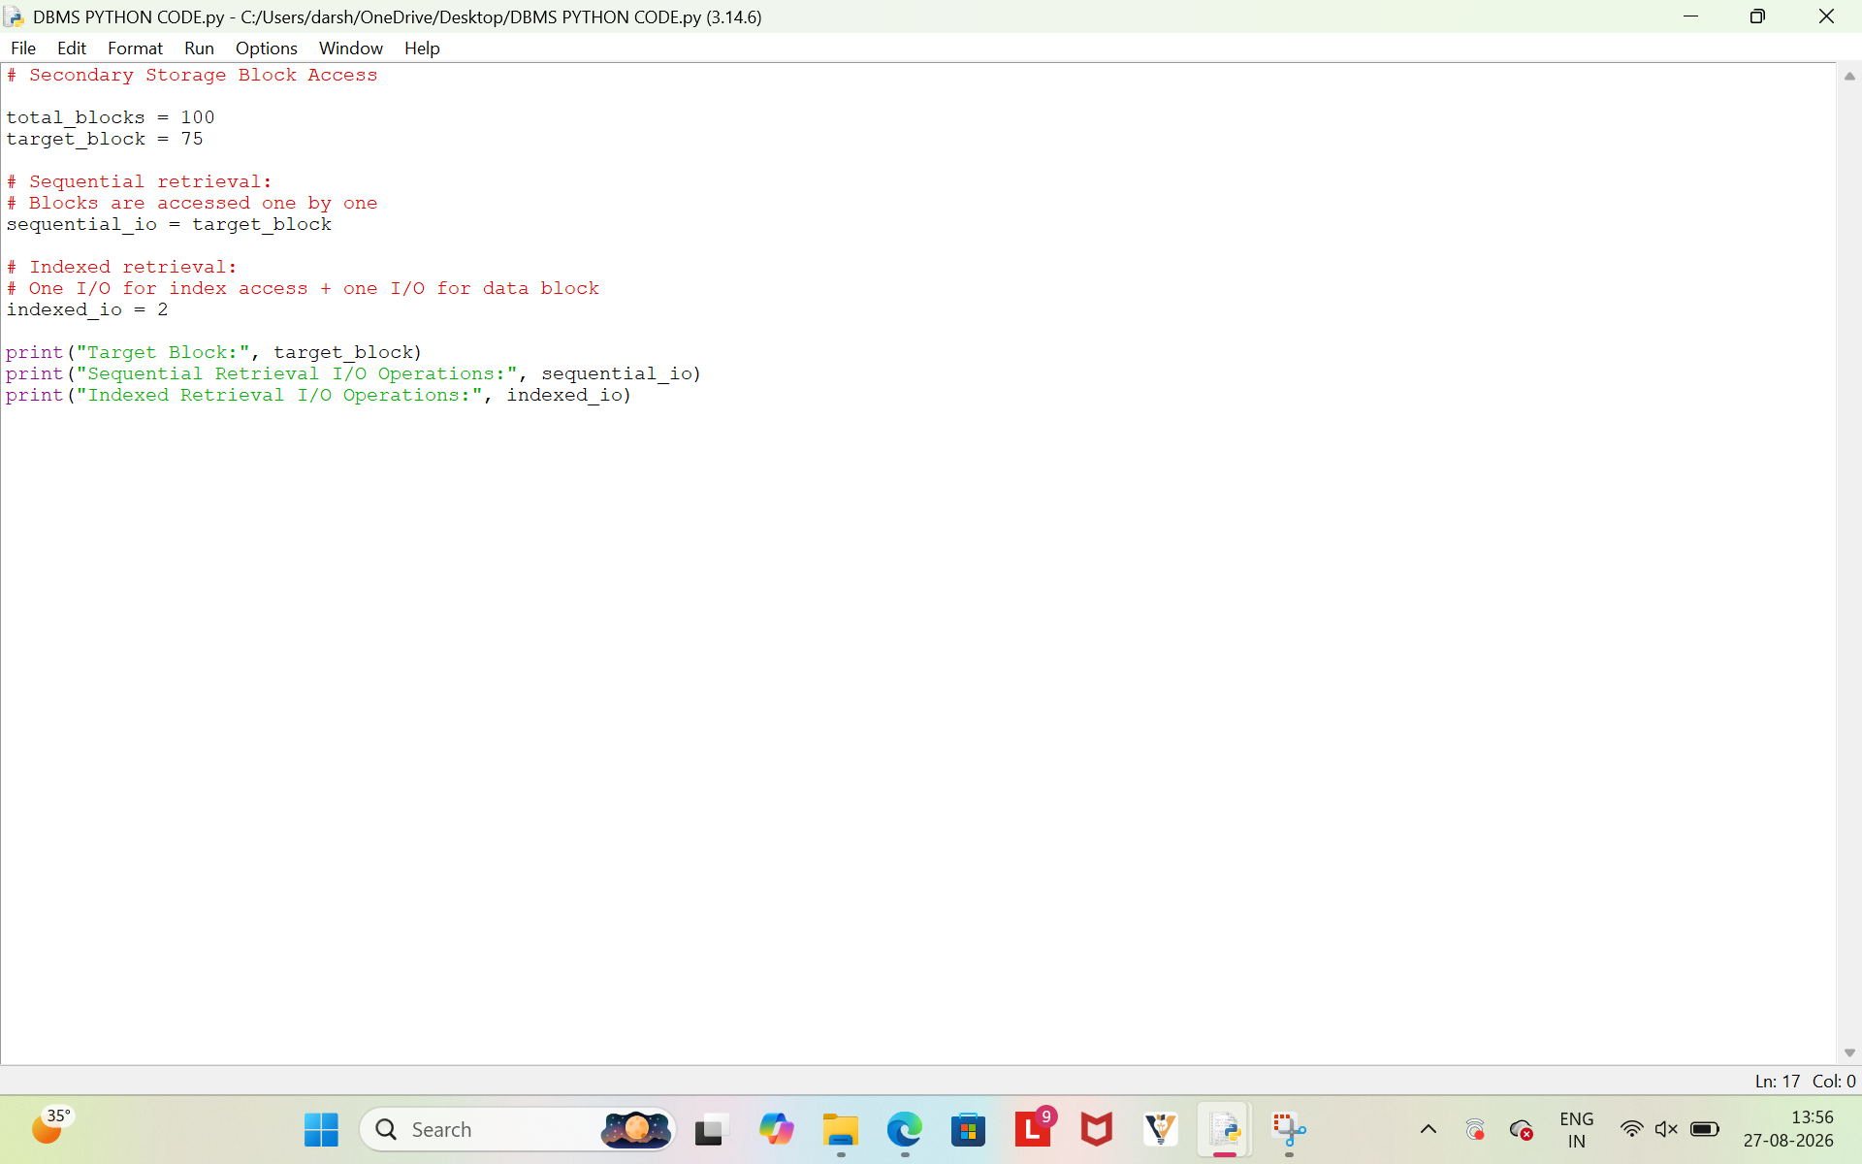
OUTPUT
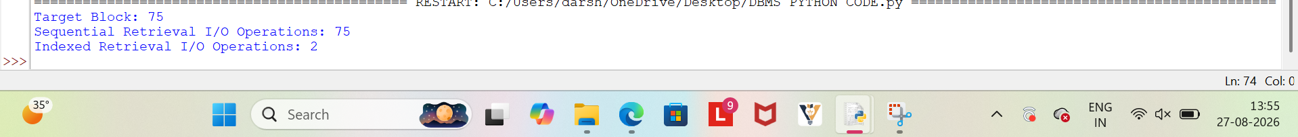

Justification
Sequential retrieval accesses blocks one by one until the required block is found.
Therefore, it may require many I/O operations for records located later in the file.
Indexed retrieval first accesses the index and then directly accesses the required data block.
Thus, indexed retrieval requires fewer I/O operations and provides faster access.

9.
CODING
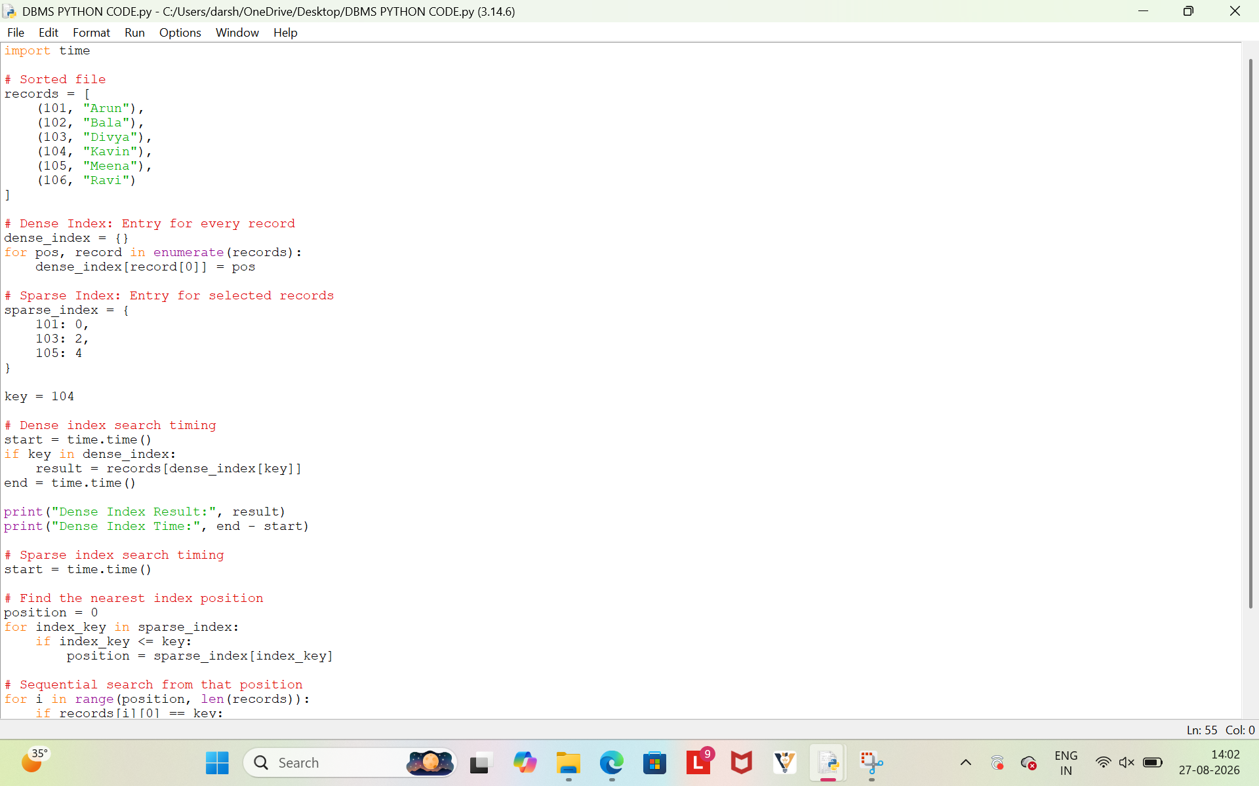
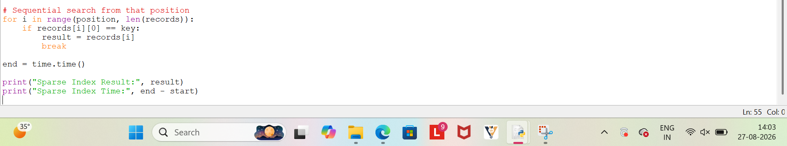
OUTPUT
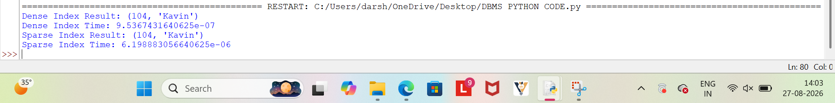

Justification
A dense index contains an entry for every record, allowing direct access. A sparse index contains entries only for selected records and then searches nearby records. Timing analysis is used to compare the search performance of both indexing methods. Thus, dense indexing is generally faster, while sparse indexing requires less storage.

10.
CODING
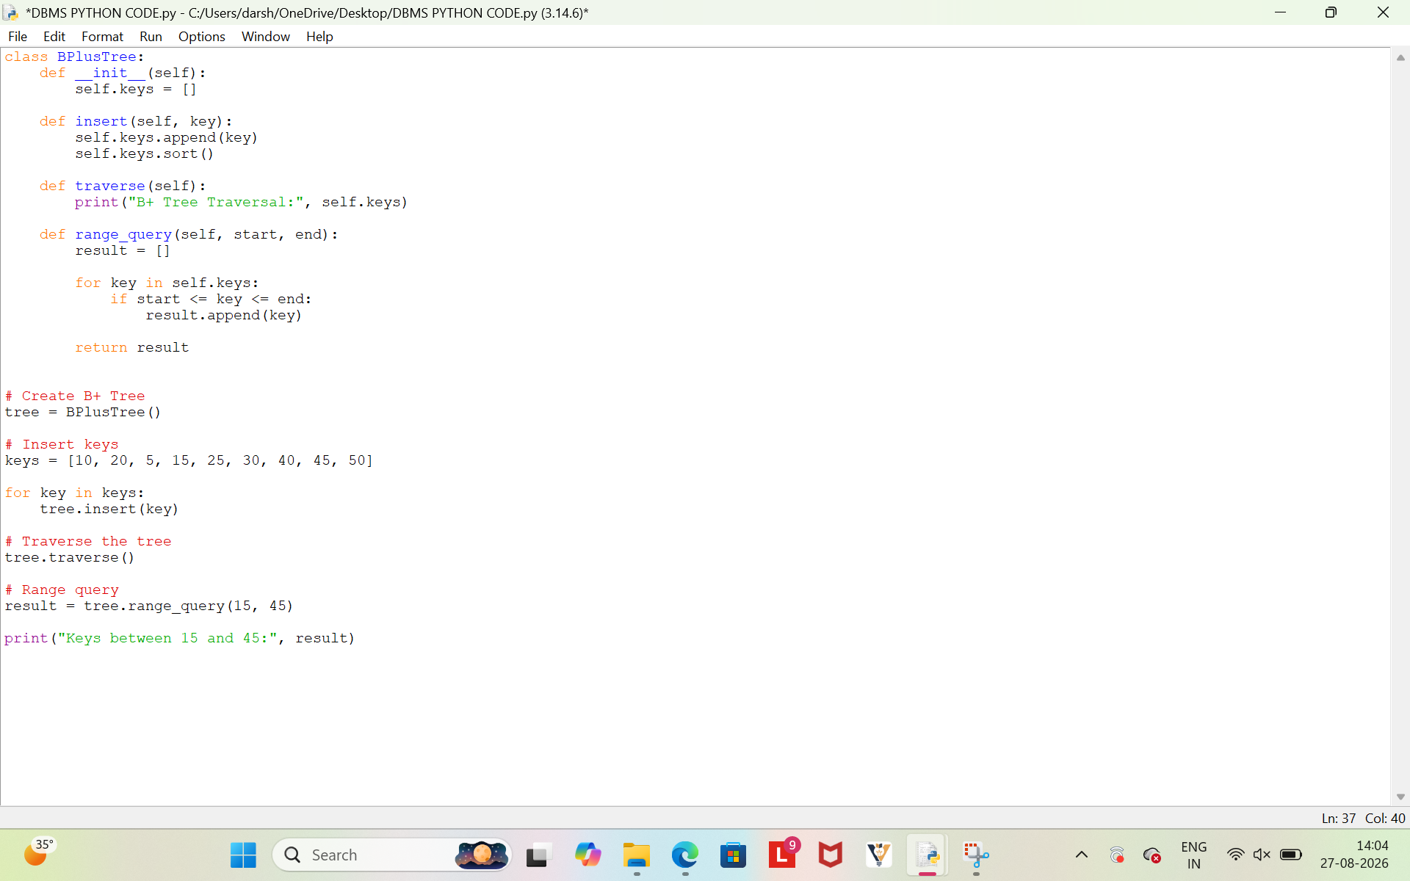
OUTPUT

Justification

The B+ Tree stores keys in sorted order for efficient traversal. The range query selects all keys between 15 and 45. The matching records are retrieved sequentially within the specified range. Thus, the B+ Tree supports efficient range-based searching.

